Summer Children’s Programs

Greenville Public Library – 618-664-3115

414 West Main Street

Saturday Story Times
Starts at 10:00 a.m.

June 9 – “Jungle Animals”

July 7 – “Arctic Animals”

August 4 – “Forest Animals”
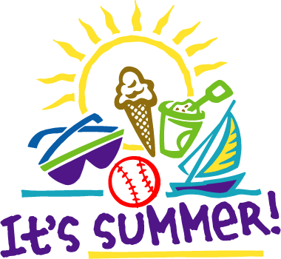

Summer Program Dates
June 1 – “Ice Cream For Books” Begins (Start your summer reading log!)
July 5 – 2:00 p.m. Shawn Cox, Music Man
July 11 – 2:00 p.m. Dr. Lynette Hemker, Veterinarian
July 18 – 2:00 p.m. Dr. Sandra Schmidt, Storyteller
July 25 – 2:00 p.m. Princess Lugge Concert
Aug 1 – “Ice Cream For Books” End

Summer Children’s Programs

Greenville Public Library – 618-664-3115

414 West Main Street

Saturday Story Times
Starts at 10:00 a.m.

June 9 – “Jungle Animals”

July 7 – “Arctic Animals”

August 4 – “Forest Animals”

Summer Program Dates

June 1 -“Ice Cream For Books” Begins
(Start your summer reading log!)
July 5 – 2:00 p.m. Shawn Cox, Music Man
July 11– 2:00 p.m. Dr. Lynette Hempker, Veterinarian
July 18 – 2:00 p.m. Dr. Sandra Schmidt,
Storyteller
July 25 – 2:00 p.m. Princess Lugge Concert
Aug. 1 – “Ice Cream For Books” Ends

